**Cyberbullying Detection Using Support Vector Machine (SVM) Algorithm**

A Thesis

Presented to

the School of Computing and Information Technology Faculty

Asia Pacific College

In Partial Fulfillment

of the Requirements for the Degree of

Bachelor of Science in Computer Science Major in Systems Software

By

Ballesteros, Faith I.

Capuz, Paulo Miguel S.

Mallari, Samantha G.

Samillano, Eva R.

**Table of Contents**

1. Introduction 4

1.1 Background of the Problem 4

1.2 Statement of the Problem 6

1.3 Objectives 6

1.3.1 Main Objective 6

1.3.2 Specific Objectives 6

1.4 Scope and Limitations 6

1.5 Significance 8

1.6 Definition of Terms 9

2. Review of Related Literature 10

2.1 Cyberbullying Literatures 10

2.1.1Social Media as its Channel and its Implications on Cyberbullying 10

2.2.2 Offline Consequences of Online Victimization: School Violence and Delinquency 11

2.2 Text Classification 12

2.2.1 Comparative Assessment of the Performance of Three WEKA Text Classifiers Applied to Arabic Text 12

2.2.2 Machine Learning Methods for Spam Email Classification 13

2.2.3 Predicting Age and Gender in Online Social Networks 15

2.2.4 Classifying Typhoon Related Tweets 16

2.3 Cyberbullying Detection 17

2.3.1 Modeling the Detection of Textual Cyberbullying 17

2.3.2 Automatic Detection and Prevention of Cyberbullying 18

2.3.3 Improved Cyberbullying Detection using Gender Information 20

2.3.4 Automated Role Detection in Cyberbullying Incidents 20

2.4 Synthesis 22

3. Theoretical Framework 24

3.1 Audience Segregation by Ervin Goffman 24

3.2 Text Classification 26

3.2.1 Support Vector Machine 27

3.3 Bag of Words 28

3.4 Performance Measures 29

3.4.1 Precision 30

3.4.2 Recall 30

3.4.3 Accuracy 31

3.4.4 F Measure 31

3.4.5 Kappa Statistics 31

4. Methodology 33

4.1 System Overview 33

4.2 System Objectives 33

4.2.1 Main Objective 33

4.2.2 Specific Objectives 33

4.3 Scope and Limitation 34

4.4 System Architecture 35

4.4.1 Data Collection 36

4.4.2 Cleaning of the dataset 37

4.4.3 Data Annotation 38

4.4.4 Tokenization 38

4.4.5 Bag-of-Words 38

4.4.6 Support Vector Machine 39

4.4.7 Cyberbullying Detection Model 39

5. Results and Discussion 41

5.1 Baseline Results 41

5.2 Percentage Split 41

5.3 K-Fold Cross Validation 42

5.4 Comparison of Machine Learning algorithms 42

5.5 Expected Output 44

5.6 Data Description 47

5.6.1 Length of words per statement 47

5.6.2 Presence of numeric data 48

5.6.3 Presence of words in uppercase 50

5.6.4 Presence of words consisting of single or double characters 52

5.6.5 Top 50 cyberbullying keywords 56

BIBLIOGRAPHY 59

# **Introduction**

# **1.1 Background of the Problem**

Recent technological advancements have extended the way people communicate. With the rise of Web 2.0, people can easily connect with one another simultaneously through chat rooms, email, instant messaging, forums, and social networking sites (Sheoran, 2012). However, alongside with the modern advancements in communication, an old pervasive issue arises with a new form in a new environment known as cyberbullying (Dadvar & De Jong, 2012). Cyberbullying is defined as an aggressive, intentional act carried out by an individual or a group through electronic means of communication, repeatedly and overtime against someone who cannot easily defend himself and can take multiple forms (e.g., threats, discrimination, and insult) in different contexts (Van Royen, Poels, Daelemans, & Vandebosch, 2015). Furthermore, it is a form of harassment that occurs via the Internet which includes vicious forum posts, name calling in chat rooms, creating fake profiles on social networking sites, and sending cruel messages (What is Cyberbullying?, 2011). Unlike the traditional form of bullying, the perpetrators of cyberbullying may use different types of communication technologies such as social networking sites to inflict harm on someone repetitively and deliberately (Boehm, 2012). Since information spread fast in the cyberspace and the number of audience is limitless, it can have deeper and longer-lasting effects than physical bullying (Campbell, 2005). According to Smith et al (2008), victims of cyberbullying may experience severe depression, low self-esteem, or even suicidal attempts.

The Philippines was recognized as the social media capital of the world, with more and more Filipinos getting inclined to different social networking sites (Ellwood-Clayton, 2006). A study conducted by We Are Social in 2017 found that Filipinos spent an average of 4 hours and 17 minutes per day on social media sites (Digital in 2017: Global Overview, 2017). However, as the number of Filipino social media users continuously increases, it consequently intensifies the problem of cyberbullying in the Philippines (Gonzales, 2014). A survey administered by Stairway Foundation Inc. revealed that 80% of Filipinos have been cyberbullied through social media (Takumi, 2016). Popular cyberbullying incidents in the Philippines are Paula Jaime Salvosa’s “Amalayer” incident (Lacuata, 2014), Raymond Malinay’s prank involvement (Tulad, 2012), and DJ Karen Bordador’s cyberbullying experience, following her arrest with her boyfriend in a drug-related buy bust operation (Torres, 2016). However, these are only few of the cyberbullying instances that has been formally reported.

The growing cases of cyberbullying led to the introduction of Anti Bullying Act of 2013, which requires all elementary and secondary school to adopt policies that will prevent and address cyberbullying in educational institutions (RA 10627: The Anti-Bullying Act, 2015). In 2015, House Bill 5718 was proposed to provide consequences for cyberbullying act wherein perpetrators shall face a penalty of six months to six years of imprisonment (Republic Act No. 10627, 2013). Social media administrators also play a crucial role in the process of combating cyberbullying by ensuring a safe environment, deleting harmful contents, and identifying perpetrators of online bullying. Furthermore, they have adopted various strategies to protect their users by preventing and intervening in cyberbullying situations. Their current practice involves having a moderator that will monitor inappropriate content which will allow them to detect cyberbullying in an early stage and to take actions thereafter. One of the most common methods used by these sites is privacy settings which allows users to limit the amount of information that can be viewed publicly. A reporting tool page was also used wherein users can report instances of online bullying directly to the administrators. Safety Mode, an opt-in setting, was introduced by YouTube to filter search results. Facebook has moderation and profanity blocklist that can be used to filter a set of harmful words on a page. Twitter offers Mute Feature that allows a user to remove a person’s tweets from his timeline without them knowing. Despite the efforts made by the authority and administrators of social networking sites, these methods were deemed to be inefficient because it is impossible to monitor all activities in the cyberspace given the vast amount of information available online. In addition to this, their methods rely heavily on the users to submit a report before taking an action. Since Philippines remains to be on a conservative level, Filipinos are often reluctant to admit that they have been cyberbullied and report a cyberbullying instance (Takumi, 2016). Thus, there is a need for technology to intervene in the process of mitigating online bullying.

To facilitate the process of monitoring online information and to track cyberbullying instances automatically and accurately, several studies were conducted towards the development of an automatic cyberbullying detection model (Dadvar et al., 2012; Dinakar et.al, 2011). Moreover, several machine learning approach to text categorization were applied to automate this process. Two of the most popular methods were Naive Bayes (Sintaha, M. Satter, S. Zawad, N. Swamaker, C. & Hassan, A, 2016; Marathe, S. & Shirsat, K, 2015) and Support Vector Machines (Van Hee et al, 2015). Their methods significantly reduced the task of the moderator in monitoring the activities in social media.

The aforementioned researches focused on dealing with cyberbullying scenarios occurring within their respective country of origin. This research, on the other hand, aims to create a cyberbullying detection model that is primarily suited to address the problem of cyberbullying in the Philippine context.

## **1.2 Statement of the Problem**

How can cyberbullying statements in Filipino be detected in social media sites?

## **1.3 Objectives**

### **1.3.1 Main Objective**

To create an application that can detect cyberbullying statements in Filipino in social media sites

### **1.3.2 Specific Objectives**

* To gather textual data for the corpus
* To perform text preprocessing
* To perform text annotation on the dataset
* To implement machine learning algorithm using weka
* To generate a cyberbullying detection model
* To develop a cyberbullying detection system
* To test the system’s performance

## **1.4 Scope and Limitations**

The corpus (dataset) currently consists of 2000 statements which were obtained from either public Facebook and Twitter posts or Youtube comments. The totality of these statements pertained to the major controversial issues in the Philippines, given that it presents a negative connotation towards a particular person or groups of people.

Text preprocessing methods that were done on the dataset include cleaning, tokenization – the process of breaking down a statement into smaller pieces, and conversion of the dataset into Bag-of-Words form. The cleaning of the dataset involved the removal of all special characters, non-readable text (e.g. asdfghjkl), emoticons, links, and foreign language characters. Basic *Jejemon* slang was included in the dataset.

Three schemes were used for text annotation or labelling namely cyberbullying, not cyberbullying, and ambiguous cyberbullying. 2000 statements were randomly distributed among Metro Manila citizens for them to annotate.

The machine learning algorithm that was utilized is the Support Vector Machine algorithm. The decision to do so was greatly influenced by the related literatures the proponents of this project have included in the document.

Cyberbullying occurrences in public social media posts expressed using the Filipino language will be detected, based on the context as to how they are typically comprehended with and/or stated by Filipinos residing within Metro Manila. 2000 statements were utilized in WEKA in order to form the cyberbullying detection model. 10-fold Cross Validation was used for determining the accuracy, precision, recall, F-measure, and Kappa statistic of the constructed cyberbullying detection model. However, only the accuracy and Kappa Statistic were used to measure the model’s performance. Overall, it yielded an accuracy rate of 57.95% and a Kappa Statistic of 20.94%. It was initially experimented on the corpus data before getting integrated with the application.

The program for the system, which will allow the automated identification and reporting of cyberbullying occurrences on Twitter - the social networking site that will be used in the project as a testing platform - to take place will be hard-coded using the Java programming language. It is expected to come in the form of a plugin or a website extension.

To test the performance of the application, it should be able to interact with Twitter API through Twitter4J. Doing so would enable the application to directly gather tweets from the site, including additional information related to the tweet such as the username of the person who posted it, and the time and date it was posted. Reports will only feature posts that were declared as cyberbullying. Likewise, their accessibility is limited to the administrators of the site. These reports will then be arranged in a tabular format. Statements that will not be flagged as cyberbullying will be disregarded. Procedures to be implemented by the authorities in order to resolve the issue will no longer be covered in this project.

## **1.5 Significance**

The main significance of this research project was aimed towards the improvement of the identification and reporting of cyberbullying occurrences in social media sites, most especially among interactions between Filipino citizens residing in Metro Manila, Philippines. As mentioned earlier, the model was designed according to cyberbullying in the Philippine setup, indicating that it will only be able to classify statements expressed in the Filipino language. Doing so would greatly benefit the majority of the people expressing themselves using this particular language, which a great number of Metro Manillans do. They will be able to entitle themselves to a more efficient way of dealing with cyberbullying which would then guarantee them a fun and safe experience in social media.

Authorities, who are mainly those people given the right to monitor social media accounts of their company or organization’s affiliates in search for inappropriate content (specifically cyberbullying) and resolve issues related to it, will likewise gain something from the fruits of this study. After all, the identification and reporting of potential cyberbullying content in the site will be automated with the aid of the algorithm. This will make their work easier and more efficient for them, as little time and effort will be exerted to complete the said task. Likewise, the reports will be done in real-time, indicating that they will be notified right away of the possible cyberbullying occurrences before it escalates.

The findings of this study will redound to the benefit of researchers who want to explore the field of both Cyberbullying and Natural Language Processing (NLP) – a field combining the areas of computer science, artificial intelligence, and computational linguistics to comprehend human languages. [19] The study provides detail on the processes of text classification and Linear Support Vector Machine Algorithm. As for the researchers who would want to explore the field of cyberbullying, this study can further enhance their knowledge on what cyberbullying is, the classification of cyberbullying and non-cyberbullying events, and the different categories of cyberbullying, based on sensitive issues in the Philippines.

Anti-cyberbullying advocates, specifically those willing to help Filipinos, will be assisted by the system in the fulfillment of their advocacies as it will create a significant leap in terms of resolving such incidents through real-time identification and reporting processes to be conducted on each statement.

## **1.6 Definition of Terms**

|  |  |
| --- | --- |
| Terms | Definition |
| Bag-of-Words (BoW) Model | A model, used in Natural Language Processing (NLP) and Information Retrieval (IR), to represent a multiset of words, disregarding grammar and word order |
| Corpus | A collection of written texts |
| Cyberbullying Detection Model | The output of WEKA toolkit when the preprocessed text (from the corpus) is integrated with Support Vector Machine (SVM) algorithm to detect Filipino cyberbullying statements online |
| Machine Learning (ML) | A type of artificial intelligence (AI) that provides computers with the ability to learn without being explicitly programmed |
| Natural Language Processing (NLP) | A field of computer science, artificial intelligence, and computational linguistics concerned with the interactions between computers and human (natural) languages |
| Social Media | Websites and applications that enable users to create and share content or to participate in social networking |
| WEKA toolkit | Consists of a collection of machine learning algorithms for data mining tasks |

# **2. Review of Related Literature**

## 

## **2.1 Cyberbullying Literatures**

Several studies in the social sciences has been devoted to understanding the nature of cyberbullying and the extent of its prevalence among children and young adults (Dinakar, Reichart & Lieberman, 2011). This section focuses on the findings of the studies conducted with regards to cyberbullying.

### 

### **2.1.1Social Media as its Channel and its Implications on Cyberbullying**

Gonzales (2014) conducted a qualitative study to explore the relationship between social media and cyberbullying. Through the use of focus interview analysis, he was able to gather information from eight experts from various field of specialization. From his study, he came up with the following conclusions:

* Social media is the root cause of cyberbullying.
* There is no specific law in the Philippines that clearly defines punishable acts for cyberbullying.
* Self-discipline must be imposed by all social media users.
* Cyberbullying can be avoided, if people have a better understanding of social media.
* Social media users should be wary of sharing personal information in the cyberspace.
* The victim should report to the authority once the bully poses a serious threat to his life or liberty.

### **2.2.2 Offline Consequences of Online Victimization: School Violence and Delinquency**

Hinduja and Patchin (2007) conducted a study to determine the relationship between victimization, strain, and deviant behavioral choices of the cyberbullying victims. Moreover, they used the general strain theory (GST) to identify both the emotional and behavioral effects of cyberbullying.

The proponents conducted an online survey methodology to obtain data from 1,388 adolescents. They used two primary independent measures (cyberbullying victimization and strain), a dependent variable (offline problem behaviors) and three demographic control variables such as age, race, and gender. Cyberbullying victimization is a scale that is composed of eight types of online victimization ranging from relatively minor forms of bullying to a more serious forms of harassment. The strain scale, on the other hand, refers to the common coping mechanism of a victim and is composed of nine items. The dependent variable is composed of an eleven-item index which represents the respondent’s behavior for the past six months. It ranges from a minor form of deviance to a more serious forms of delinquency.

For their experiment, a series of stepwise ordinary least squares (OLS) were estimated to explore the relationship between cyberbullying victimization, strain, and offline problem behaviors. In total, three models were created. The first model shows the relationship between cyberbullying victimization and offline problem behaviors, the second model illustrates the relationship between strain and offline problem behaviors, and the third model illustrates the relationship between cyberbullying victimization and strain and offline problem behaviors. As shown in Table 2.0, the first model proves that cyberbullying victimization is significantly related to offline problem behaviors which means youth who experience cyberbullying are more likely to participate in problem behaviors offline. The second model shows that strain is positively related to offline problem behaviors. Thus, youth who experience more strain are more likely to engage in offline problem behaviors. The third model illustrates that strain has a significant relationship with delinquency. The result of the third model demonstrates that strain serves as a mediator for the relationship between cyberbullying victimization and offline problem behaviors mainly because strain can be attributed on the effect of cyberbullying victimization on offline problem behaviors.

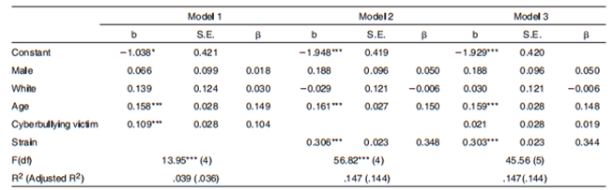

*Table 2.0: Ordinary Least Squares Regression - Delinquency Regressed on Strain and Cyberbullying Victimization*

## **2.2 Text Classification**

Recently, various machine learning approaches for automated text classification has witnessed a surge in terms of application (Sebastiani, 2002). This section presents the different applications of text classification including the methods that were employed by the researchers. It also presents the comparison of each approach when applied to different classification problems.

### **2.2.1 Comparative Assessment of the Performance of Three WEKA Text Classifiers Applied to Arabic Text**

Wahbeh and Al-Khabi (2012) conducted an experiment to illustrate the performance of three different text classification techniques: SVM, Naïve Bayes, and C4.5 in classifying Arabic text documents.

The first phase of their experiment begins with the creation of the corpus by gathering Arabic text documents from different websites: Kooora, news-all, and from Saheeh Al-Bukhari book and other websites. These data were already classified into number of categories such as Sport, Economic, Religion, Politics, and Mohammed sayings. They gathered a total number of 1000 documents (250 documents for each category) for their corpus.

As for the preprocessing step, any occurrences of digits and punctuation marks were removed.  Next, the set of characters were normalized into a canonical form. Third, non-Arabic text, special characters, and stop words were also removed. The last step involved in pre-processing includes the tokenization of the documents. All of the preprocessing steps were done using a tool created in C#. These documents were converted into ARFF format by utilizing WEKA TextDirectoryToArrf converter and StringToWordVector.

For their preliminary experiment, they utilized the percentage split which involves the process of dividing the data into two partitions: 60% was used for training phase while the remaining 40% was used for testing phase. Furthermore, they used 10-fold cross-validation technique for both dataset. These experiments were done to know if there will be improvements in the accuracy when the 10-fold cross-validation method is applied instead of the percentage split alone. Table 2.2 shows the comparison of the performance of three classifiers with respect to the percentage split method and 10-fold cross-validation. As shown in Table 2.2, the 10-fold cross-validation has significantly improved the accuracy for each classifier.

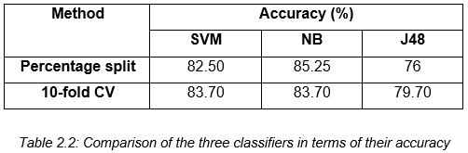

Aside from the accuracy of each classifier, they also measured the time taken for constructing each model. As shown in table 2.3, SVM requires the shortest amount of time to build the model. It was followed by the NB classifier. Lastly, J48 requires the largest amount of time in building the model.

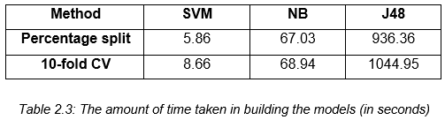

### 

### **2.2.2 Machine Learning Methods for Spam Email Classification**

Awad and Elseuofi (2011) compared the performance of different machine learning algorithms in classifying spam emails. Their experiment begins with the construction of a corpus by compiling both spam and legitimate emails from SpamAssassin, a collection of publicly available emails. This collection contains a total number of 6000 emails. Their dataset was divided the corpus into two sets: training and testing.

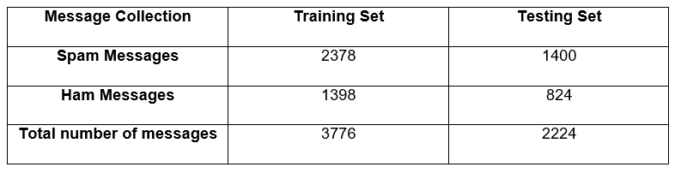  
*Table 2.4: Corpora of Spam and Ham Messages*

Each email was further divided into three different parts: subject (the title of the email), from (the name of the sender) and body (the main part of the message). The preprocessing steps involve the removal of common words and case-change, wherein each word in the body is converted into small letters. Each message was converted to a feature vector which results into 21,700 attributes.

They selected a number of 100 features. These features were the most frequent words in spam mails. In addition to this, every email in the training dataset was denoted as a feature vector. Once the preprocessing steps were done, they applied different machine learning algorithms: Naïve Bayes, K-Nearest Neighbor, Artificial Neural Networks, Support Vector Machine, Artificial Immune System, and Rough Sets. To evaluate the performance of each classifier, they used precision, recall, and accuracy. As shown in Table 2.5, Naïve Bayes outperformed the other classifiers in terms of precision, recall, and accuracy.

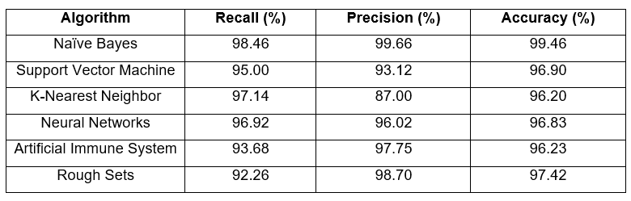  
*Table 2.5: The performance of different machine learning algorithms in spam email classification*

### **2.2.3 Predicting Age and Gender in Online Social Networks**

Peersman, Daelemans, and Vaerenbergh (2010) conducted a study to explore the feasibility of detecting age and gender using statistical text classification and the usefulness of this approach when applied to short texts.

The experimentation phase begins by obtaining 1,537,283 Flemish Dutch posts from Netlog. Relevant information such as age and gender of the authors were also identified in the corpus. The first step in pre-processing involves extracting only the last post of each interaction. Tokenization was also applied to the dataset, which results into a total number of 18,713,627 tokens. Moreover, each token was converted to a lowercase and four or more consecutive identical characters were reduced to three. The third step in pre-processing involves grouping the data using the profile data. In this step, the corpus is divided into following subclasses: min16 (from 11 to 15 years old), plus16 (16 and older), plus18 (18 and older) and plus25 (25 and older). The metadata for both genders were also incorporated and the following classes were derived: min16_male, min16_female, plus25_male and plus25_female. For their experiment, they used 10,000 posts per class and then we first set up our experiments with 10,000 posts per class and then subsequently decreased it to 5000 and 1000 posts per class.

For the feature selection process, they applied the Chisquare (χ2) metric. The feature set was limited to token and character features: word unigrams, bigrams and trigrams, character bigrams and trigrams, and tetragrams. The feature sets were built by selecting the 1000, 5000, 10,000 and 50,000 features with the highest Chisquare values. Once the features have been selected, each document is represented as a binary vector for the SVM classifier. Moreover, the SVM classifier was trained using Liblinear package. The performance was evaluated using 10-fold cross validation as experimental regime.

In their first experiment, they reduced the number of classes in both train and test sets from the four complex classes to two in order to compare the result to those from the first dataset, which was balanced according to age only. In their second experiment, the classifier was trained into four complex classes then the number in the classifier’s output was reduced to two classes in order to determine whether the extra gender information the classifier had acquired would generate to a better age prediction on the test sets. The third experiment involves the reduction of the number of classes in both training and test sets to two age classes and gender was included as an extra feature in every instance. Table 2.6 illustrates the overview of the results of the three experiments in comparison with the first dataset.

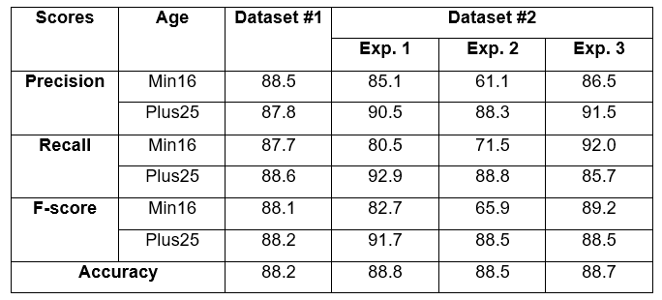  
*Table 2.6: The result of the three experiments in comparison with the first dataset*

### 

### **2.2.4 Classifying Typhoon Related Tweets**

In a study conducted by Lam, Paner, Macatangay, and Delos Santos (2014), they illustrated the classification of typhoon related tweets into six categories:

• Resource coordination  
 • Urgent rescue needed  
 • Urgent rescue resolution  
 • Damage reporting  
 • Missing people  
 • Media storm coverage

The experimentation phase begins with the collection of 2,356 tweets using Tweet Miner. Furthermore, these data were stored in the SQLite database.  The preprocessing steps involve the filtering of tweets that do not contain an official hashtag. Moreover, each data in the set were converted into lowercase for two main purposes: to normalize the tweet by removing duplicate words from inconsistent casing and to remove official hashtags. All of these steps were done using Tweet Filter. Additionally, the filtered tweets are converted into BoW representation in ARFF format.

For their experiment, they trained both SVM and Naïve Bayes classifiers in WEKA. Furthermore, these classifiers were tested using ten-fold cross validation. For the evaluation metrics, they used precision, recall, f-score, and kappa statistics. As shown in Table 2.7, the SVM classifier outweighs the performance of Naïve Bayes classifier in both metrics.

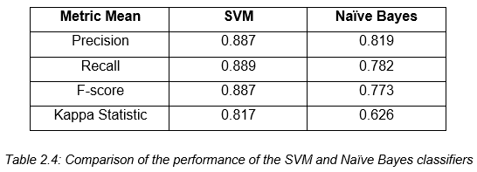

*Table 2.7: The comparison of the performance of SVM and Naïve Bayes*

## 

## **2.3 Cyberbullying Detection**

Several studies have been conducted in automating the detection of cyberbullying on social networking sites to flag harmful messages and prevent these messages from remaining in the cyberspace by providing timely responses (Van Royen, Poels, Daelemans & Vandebosch, 2015). This section focuses on the various methods used by different researchers in automating the process of detecting cyberbullying. It also examines the effectivity of each approach.

### 

### **2.3.1 Modeling the Detection of Textual Cyberbullying**

Dinakar, Reichart, and Lieberman (2011) proposed a method in creating a cyberbullying detection model. Their experiment begins with the creation of a corpus composed of YouTube comments by using YouTube PHP API. They were able to obtain a number of comments that exceeds 50,000. The comments were partitioned into clusters of physical appearance, sexuality, race and culture, and intelligence. In addition to this, 1500 comments from each clusters were annotated to three categories: sexuality, race and culture, and intelligence. As for those comments that were not related to the cluster, they were given a label “none”. Each dataset was subjected to four operations: the removal of stop-words, stemming, removal of unnecessary sequence of characters, and cleaning. The dataset for each cluster were further divided into three partitions: 50% training, 30% validation and 20% test data. Moreover, they used four supervised learning methods: Naïve Bayes, SVM, JRip, and J48.

They extracted two kinds of feature from each dataset: general features and specific features. The general features were common across all datasets for both experiments and they are composed of: TF-IDF, Ortony lexicon for negative, list of profane words, and POS bigrams (JJ_DT, PRP_VBP, and VB_PRP). The label specific-features are composed of topic specific unigrams and bigrams. To measure the effectivity of each classifier, they used accuracy and kappa statistics.

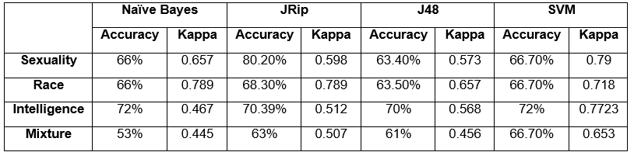  
*Table 2.9: The comparison of the performance of Naïve Bayes, JRip, J48 and SVM*

As shown in Table 2.9, JRip yields the best performance in terms of accuracy while SVM is the most reliable as measured by kappa statistics. In addition to this, the binary classifiers trained for each individual labels performed better than multi-class classifiers trained for all the labels.

### **2.3.2 Automatic Detection and Prevention of Cyberbullying**

In the experiment of Van Hee et. al (2015), they proposed a method for automating the identification of cyberbullying events and their classification into cyberbullying categories. The experimentation phase begins with the creation of corpus by collecting 91, 370 Dutch posts from Ask.fm. Moreover, they illustrated two levels of annotation: First, the assignment of harmfulness score to the post on a three-point scale wherein 0 indicates non-cyberbullying event, 1 indicates mild cyberbullying event, and 2 indicates severe cyberbullying event. Moreover, the roles in a cyberbullying event were also identified: victim, harasser, bystander-defenders (who discourage the harasser) and bystander-assistant (who take part in the actions of the harasser). At the second level of annotation, each data was classified into fine-grained text categories related to cyberbullying: insults, threats, sexual talk, defamation, defense and curse. In total, 85,462 Dutch posts were successfully annotated using brat rapid annotation tool. Moreover, the interannotator agreement scores were calculated using Kappa. They obtained a Kappa score of 0.69 in the identification of cyberbullying events. Additionally, the Kappa scores for the fine-grained cyberbullying categories such as Threat, Insult, Defense, Sexual Talk vary from 0.52 to 0.66.

The preprocessing steps involved tokenization, PoS-tagging and lemmatization to the data by utilizing LeTs Preprocess Toolkit. They implemented two types of lexical features for their experiment: bag-of-word features and polarity features based on existing sentiment lexicons. Thus, it results into a set of 300,000 features. The proponents utilized a Support Vector Machine (SVM) as their classification algorithm. All of their experiments were carried out using Pattern.

For their preliminary experiment, the evaluation was done using 10-fold cross-validation. Moreover, they used F-score for their evaluation metric. Table 2.10 shows the result of their preliminary experiment by using F-score.

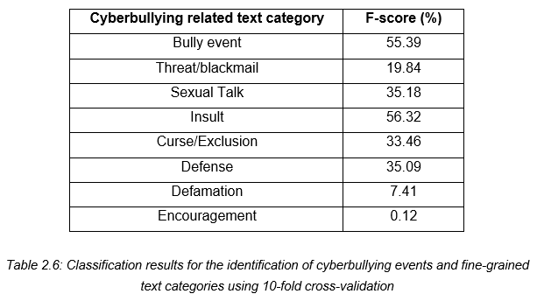

*Table 2.10: Classification results for the identification of cyberbullying events and fine-grained text categories in terms of F-score*

Table 2.11 illustrates the performance of both precision and recall with regards to the identification of cyberbullying event and their classification into fine-grained text categories.

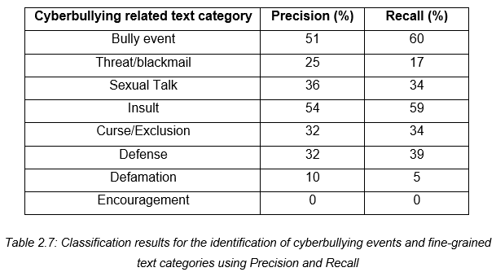

*Table 2.11: Classification results for the identification of cyberbullying events and fine-grained text categories in terms of precision and recall*

### **2.3.3 Improved Cyberbullying Detection using Gender Information**

Dadvar, Jong, Ordeiman, and Trieschnigg (2012) believed that the incorporation of gender specific language features will improve the accuracy of a cyberbullying detection system. To test this idea, they conducted an experiment on improving cyberbullying detection with the aid of gender specific features.

Their dataset was composed of MySpace posts provided by Fundacion Barcelona Media. In total, the corpus contains 381,000 posts wherein 34% was written by male and 67% were from female. However, they were only able to utilize 2,200 posts for their experiment. Furthermore, the dataset was annotated into two categories: harassing and non-harassing. They analyzed the use of foul words among the 100,000 posts and compared the most frequently used foul words by each gender. By utilizing Wilcoxon signed rank test, they were able to determine the different frequencies of foul words in each gender.

For harassment classification, they utilized four types of features: first, profane words (including their acronyms and abbreviations), personal pronouns, second person pronouns, and TFIDF. These features were employed to train the classifier. Moreover, they constructed a Support Vector Machine (SVM) classifier in WEKA. First, they utilized the posts written by both genders as their dataset, then they trained the classifier separately for each respective gender group. In evaluating the accuracy of the classifier, they used 10-fold cross validation and calculated its precision, recall and F-measure. As shown in Table 2.5, the incorporation of gender-specific features improved the overall accuracy measures.

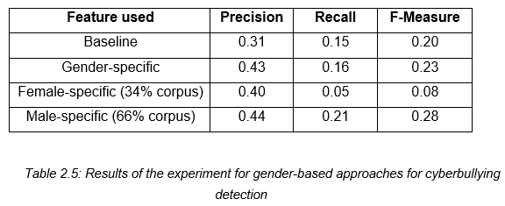

*Table 2.12: The result of improving cyberbullying detection using gender-specific features*

### 

### **2.3.4 Automated Role Detection in Cyberbullying Incidents**

Cheng and Ng (2016) conducted an experiment on the detection of cyberbullying roles. Their experiment begins with the creation of a corpus by gathering data from Facebook and Youtube. In total, 6000 posts/comments written in both English and Tagalog were collected (1500 for YouTube and 4500 for Facebook). The dataset was cleaned by removing unnecessary symbols. Furthermore, it underwent normalization through the use of NormAPI. Lastly, each data was manually annotated into six classes: Bully, Accuser, Defender, Reporter, Victim, and N/A (which pertains to the instances that do not belong to the any of the class).

They implemented four types of features for their experiment: bag-of-word, TF-IDF, profane words, and word shape or the instances written in all uppercase. The experiment was conducted 7 times, each with a different set of role classes. The combination of the roles is as follows:

* All classes
* Bully and N/A (Bull + N/A)
* Accuser, Bully, and N/A (Acc + Bull + N/A)
* Bully, Defender, and N/A (Bull + Def + N/A)
* Bully, N/A, Reporter, and Victim (Bull + N/A + Rep + Vic)
* Accuser, Bully, Defender, Reporter, and Victim (All except N/A)
* Accuser, Bully, and Defender (Acc + Bull + Def)

For their first experiment, they used an initial set of 25 word features in each class. They checked the presence of both words that are written in all capital letters and those which contains profanity. From a total number of 150 features, it was decreased into 93 unique word features. Their second experiment involves the removal of both intersecting words and other added features. Thus, if a word feature is found in more than 1 class it will be removed in the feature set. The total number of 150 features was decreased into 63. As shown in Table 2.9, there was a decrease in all measures. Their third experiment involves the removal of both profanity and all capital words as features. In this experiment, the model was able to predict more bully and defender roles by removing both profane and full capital words.

For their fourth experiment, they utilized a weighting system that will assign weights to word features. This experiment was done in order for the model to be able to distinguish the respective classes for each feature. There was a significant improvement in the results as compared to the previous experiments. Thus, the assignment of weights can further help the classifier in identifying the features for each of the classes. The next experiment involves adding more features to the current set. Some word features were replaced with more relevant ones such as nouns and proper nouns. More common words were also removed in this phase. The initial number of 25 word features per class was increased into 50. The last experiment obtained a highest accuracy compared to the previous ones. Thus, by adding more relevant features, the roles of the bully, accuser, and victim were able to have more correctly classified instances.

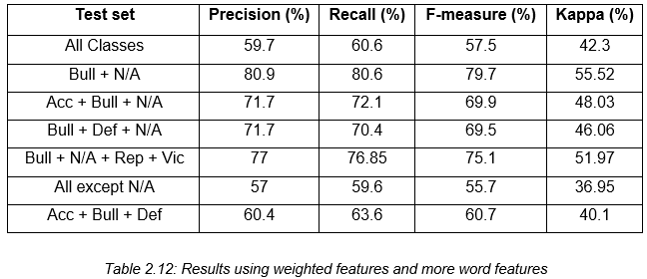

*Table 2.12: The result of the last experiment*

Lastly, the experiment that yield the highest accuracy was tested using different algorithms: Naïve Bayes, J48 and Support Vector Machine. As shown in Table 2.12, among the three algorithms that were utilized, SVM yield the highest accuracy.

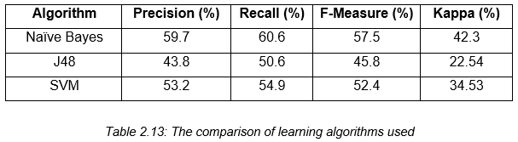

*Table 2.13: The comparison of the performance of Naïve Bayes, J48 and SVM*

## 

## **2.4 Synthesis**

As shown in the previous studies, several approach were used by the researchers in creating a cyberbullying detection model. Different sources and number of datasets vary from one study to another. Dinakar, Reichart, and Lieberman (2011) used 50,000 data from YouTube, Van Hee et. al (2015), collected 91, 370 Dutch posts from Ask.fm, Dadvar, Jong, Ordeiman, and Trieschnigg (2012) utilized a number of 2,200 posts from MySpace, while Cheng and Ng (2016) gathered 6000 posts from Facebook and YouTube. The present study gathered a total number of 2000 data from YouTube, Twitter, and Facebook. These studies focused on collecting posts written in English aside from Van Hee et al. (2015) who collected Dutch posts for their dataset. The present study further enhances the capability of a cyberbullying detection model by detecting posts written in both English and Tagalog. The researchers also classified their data into different categories: Cyberbullying Roles (Cheng and Ng, 2016), Harassing and Non-Harassing (Dadvar, Jong, Ordeiman, and Trieschnigg, 2012), Insults, Threats, Sexual Talk, Defamation, Defense and Curse (Van Hee et. al, 2015), and Sexuality, Race, and Intelligence (Dinakar, Reichart, Lieberman, 2012). The way they pre-processed their data also varies from one another: For the present study, they only focused on classifying cyberbullying and non-cyberbullying instances. The performance of the models were measured through Precision, Recall, F-Measure, Kappa score, and Accuracy. However, as for this study, the model’s performance was measured by Accuracy and Kappa score alone. As seen in the previous studies, the performance of SVM was compared to algorithms such as JRip, J48, and Naïve Bayes. This study aims to improve the previous studies by comparing SVM into several machine learning algorithms in WEKA namely: Naïve Bayes, J48, JRip, ZeroR, Decision Stump, RandomTree, RandomForest, RepTREE, HoeffdingTree, DecisionTable, and OneR. The reason for this is to determine if SVM is the best algorithm that can be used for this kind of classification problem. Lastly, the previous studies merely focused on improving the performance of cyberbullying detection model. Thus, the present study aims to further enhance what has been started by the previous researchers by surpassing the technological feasibility of automating the detection of cyberbullying occurrences into automating the generation of reports once a cyberbullying post has been detected.

# 

# **3. Theoretical Framework**

## **3.1 Audience Segregation by Ervin Goffman**

In his book “The Presentation of Self in Everyday Life”, Ervin Goffman introduced the mechanisms of audience segregation. He describes how people play different roles in different situations. It is a mechanism wherein an individual performs roles, in order to create a favorable image of themselves and leave a good impression to others that is linked to the role they perform. The role that the individual performs is based on who their audience is.

Nowadays, more and more people are getting inclined to social networking sites because it provides an easier way for social interactions and communications. These sites allow users to share personal information about themselves through text, pictures, and other forms of media which in turn, creates an image for each user; however, the representation of oneself in the cyberspace is on a global scale in front of an audience which is possibly unknown and infinite. In social networking sites, the user’s privacy is threatened because a large audience might have access to his personal information. In order to handle privacy issues, there were few social media sites that offer limited options for making one’s profile visible for a specific set of individuals. As for some cases, audience segregation is used as a solution to protect user’s privacy; however, Goffman’s segregation of audiences is a lot harder in the era of the Internet. Difficulties begin when the audience is used to a certain type of performance from an individual or team but observes another performance which does not create the same impression which results to cyberbullying. The impression created on a social networking profile may not resemble an individual’s real life identity.

The nature of communicating in the cyberspace facilitates the potential for anonymous interactions. It was discovered that bullies who choose to use electronic means can easily hide their real identity and make themselves anonymous. Anonymity can be created through the use of temporary email addresses, fictitious names or unknown mobile number. The perception of anonymity in social media serves as a disinhibitor so that people are more likely to do and say things online that they would not do or say in a face to face situation. Another key characteristic of cyberbullying is the potential to reach a limitless audience. Due to the boundless nature of cyberspace, the audience is not confined to a single setting (such as school or office) but has the potential to be viewed by a global audience.

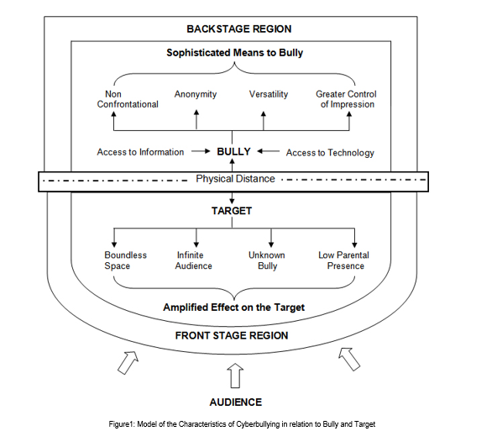

Goffman's framework offers not only a way of thinking about space in terms of performance but also a way of thinking about how people may act differently depending on the audience and setting which are relevant to an exploration of cyberbullying. Goffman defined three roles in this mechanism: performer, audience, and outsider. These roles can be paralleled to the roles of a target, bully, and bystander. By framing bullying as a performance, a framework is provided that enables us to consider the bystander group as an audience and how different settings may affect how young people act towards others. In order to set the scene for a performance, Goffman made a distinction between the two regions of social space where an individual interacts. The front region is defined as the public performance area. The backstage region is a place wherein the performer can privately prepare for the performance or where members of a group can openly construct the impression they are planning to give. By using Goffman’s framework of performance, cyberspace interactions can be executed by the bully in the backstage region which impacts on the target in the public front stage region. As the backstage region is a place that performers may privately prepare away from the audience, this provides time and space for the bully to plan the ways in which they wish to target others. The physical distance which cyberspace interactions facilitate may also result in the bully managing the impression ‘given off’, the ability for the bully to conceal their identity and the tone and meaning being open to wider interpretation.

## **3.2 Text Classification**

Machine Learning focuses on building systems that can learn from examples. It aims to automate the process of learning in order to make accurate predictions through the use of examples. In relation with NLP, Machine Learning is used to understand the meaning of natural language, therefore, machines have to learn how to do it. One of the examples of how Machine Learning and Natural Language Processing can be leveraged to enable machines to better understand human language is text classification. In text classification, each text document is classified into one or more categories. Since the manual process of categorizing documents can be a laborious task especially if there are several number of documents, machine learning automates the process of text classification.

With the aid of machine learning, the goal of text classification is to build classifiers by learning the characteristics of the categories from a set of pre-classified documents (Sebastiani, 2002). There are several kinds of classifiers that are suitable for different text classification problems. Therefore, choosing the right classifier is crucial for the performance of the program. The decision criterion of a classifier is learned automatically from the training data. Thus, once the classifier has been trained, it can predict the category of the new data. This approach is also called statistical text classification.  Figure 3.3 illustrates the process of statistical text classification.

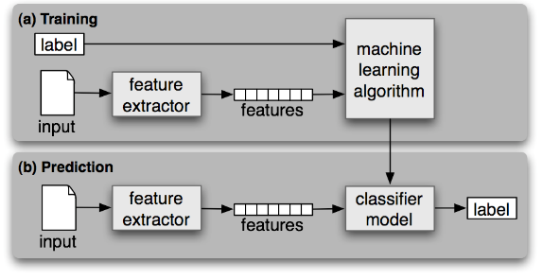

*Figure 3.3: Statistical Text Classification*

As shown in Figure 3.3, the process of statistical text classification begins with feature extraction wherein a feature extractor is used to convert each input value to a feature set, which captures the relevant information about each input that will be used in order to classify them. Both features and labels are fed into the machine learning algorithm in order to generate a model. During prediction, the same feature extractor will be used to convert new inputs into feature sets. These feature sets are fed into the model, which in turn, will produce predicted labels.

Some applications of text classification are spam filtering, email routing (Busemann, Schmeier & Arens, 2000), language identification, and genre classification (Litvak & Last, 2008).

### **3.2.1 Support Vector Machine**

In a machine learning approach to text classification, an algorithm will be used in learning how to classify documents by producing a model to map the input and output. One of the most popular models used in text classification is linear model, which uses the linear combination of feature-values. There are several linear models and one of the most commonly used model is Support Vector Machine (SVM).

Vapnik et al. developed Support Vector Machine, a supervised learning model that is used to analyze data in text classification or regression. It is based on Structural Risk Minimization principle from computational learning theory. SVM performs classification by creating a k-dimensional hyperplane that separates the data into two categories. The number of dimension is equivalent to the number of features an object can possess. In text classification, a feature can be a number of occurrence of particular word in the whole document.

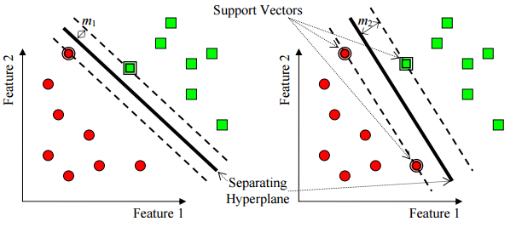

*Figure 3.4: Support Vector Machine with two features*

In a set of training examples wherein each data has already been labeled, an SVM training algorithm produces a model that will assign new examples to one of the categories which makes it a non-probabilistic binary linear classifier. An SVM model represents the examples (or support vectors) as points in space. SVM seeks to find a line (or hyperplane) that separates the examples based on their labeled classes. The two dashed lines drawn in parallel to the hyperplane represents the distance between the hyperplane and the closest vectors to the line. Moreover, the distance between a dashed line and the hyperplane is called the margin. Thus, whenever a data is added, the side of the hyperplane where it lands will determine the class that will be assigned to it. Figure 3.4 illustrates how SVM works with two features wherein points are plotted on a 2-dimensional plane.

## **3.3 Bag of Words**

In statistical text classification, each input is treated as a feature vector. One of the most common methods used in transforming a text document into a feature vector is through the use of “bag-of-words” representation, in which a set of text documents is converted into a numeric feature vectors wherein the order of word occurrences and grammar are ignored. Moreover, it is defined as an order less document representation (Salton & McGill, 1983). In this model, the count of words is given the utmost importance. Each word is represented by a vector of the word counts that appear in the whole document. In this scheme, each individual token occurrence frequency is treated as a feature. Regardless of the simplicity of Bag-of-Words in data representation, it often achieves high performance. (Lewis, 1992).

Once the text has been converted into a BoW model, various measures can be computed to characterize the text. One of the most popular type of features from the BoW model is term-frequency, the number of times a certain term appears in the text. However, term frequency is not considered as the best representation for the text. Oftentimes, insignificant words (such as articles) always yield the highest frequency in the text. These limitations led to the introduction of Term Frequency – Inverse Document Frequency which seeks to diminish the weight of terms that occur very frequently in the document and increases the weight of terms that occur rarely (Jones, 1972).

In the concept of TF-IDF, the high weight is conceived by a high frequency and a low term frequency in the whole document. Thus, the weights tend to filter out common terms. The ratio in the idf log function is always higher than or equal to 1, while the value of idf is always higher than or equal to 0. Moreover, when a term appears frequently in the documents, the ratio inside the logarithm approaches 1, bringing the idf and tf-idf closer to 0 (Josef, 2009).

## **3.4 Performance Measures**

Most evaluation for document classifier is conducted experimentally. Thus, it is used to measure its effectiveness or the quality of its predictions on the classification of data. Predictions made are either considered Positive or Negative and expected judgments are called True or False (Pinto, Olieveira & Alves).

As shown in Figure 3.5, a confusion matrix is a table that has two rows and two columns which shows the total number of false positives, false negatives, true positives, and true negatives. Moreover, it allows more detailed analysis than a mere proportion of correct guesses (or accuracy).

* True positive refers to the number of examples predicted positive that are actually positive
* False positive refers to the number of examples predicted positive that are actually negative
* True negative refers to the number of examples predicted negative that are actually negative
* False negative refers to the number of examples predicted negative that are actually positive

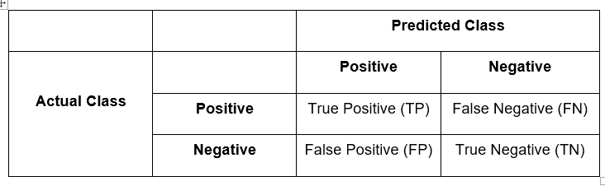

*Table 3.5: Confusion Matrix*

### **3.4.1 Precision**

Precision is used to measure the exactness of the classifier. Moreover, it refers to the fraction of predicted positive which are actually positive. It is also called positive predictive value (PPV). A high precision indicates less false positives, while a classifier with a low precision means there are more instances of false positives. Precision can be improved by decreasing the recall.

The formula for precision is the number of positive predictions divided by the total number of positive class values predicted.

### **3.4.2 Recall**

Recall refers to the fraction of those that are actually positive that were predicted as positive. It is used to measure the completeness of a classifier. Moreover, it is also called the true positive rate or sensitivity. Higher recall indicates less instances of false negatives, however, a classifier with lower recall means there are more instances of false negatives. Recall can be improved by decreasing the precision primarily because it is harder to be precise as the number of samples are increasing.

The formula for recall is the number of positive predictions divided by the number of positive class values in the test data.

### **3.4.3 Accuracy**

The accuracy is the percentage of instances that were correctly classified into their respective classes. It is also called sample accuracy.

One of the disadvantages of accuracy is it can yield to misleading result if the dataset is unbalanced or the number of samples in different classes vary. To illustrate, a model can predict the value of the class with the highest number of samples for all predictions and achieve a high classification accuracy.

### **3.4.4 F Measure**

The F-measure (or F-score) is used to measure the accuracy of the test by considering both precision and recall in computing the score. It conveys balance between precision and recall wherein it reaches its best value at 1 and its worst value at 0.

Two of the commonly used F measures are measure and measure. The measure puts more emphasis on the false negatives by weighing recall higher than precision. measure puts more emphasis on reducing false negatives by weighing recall lower than precision.

### **3.4.5 Kappa Statistics**

Interobserver agreement is a procedure to enhance the believability of data by comparing observations from two or more people who are evaluating the same thing. In evaluating, the observers would agree just by chance. Thus, kappa provides numerical rating of the degree to which this occurs. The calculation is based on the difference between the numbers of agreement that are actually present compared to the numbers of agreement that would be expected to be present by chance.



Figure 3.5 illustrates how Kappa measure the differences by standardizing into a -1 to 1 scale.

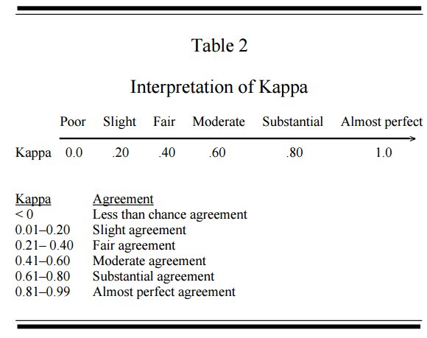

*Figure 3.5: Kappa Interpretation*

# **4. Methodology**

## **4.1 System Overview**



*Quickgarde* is a plugin or website extension that can identify possible occurrences of cyberbullying, and subsequently creates a report, regarding the detected post, that is exclusively accessible by an authorized personnel – the person who has the authority to monitor the site. it was designed to work in social media environment, particularly among public conversations expressed in Filipino.

## **4.2 System Objectives**

### **4.2.1 Main Objective**

The aim of the software is to be able to automatically detect, and subsequently flag, statements that imply cyberbullying and produce reports accordingly

### **4.2.2 Specific Objectives**

* Identify cyberbullying statements from non-cyberbullying ones in the site
* Flag detected cyberbullying occurrences in the background
* Produce organized reports, that can only be accessed by authorized personnel, in real-time

## **4.3 Scope and Limitation**

*Quickgarde* is a plugin that can detect, flag, and report cyberbullying occurrences. It covers only harmful posts written in the Filipino language (English and Tagalog). Moreover, it’s functionalities are limited only to textual data. The system was programmed in Java. It will be tested in Twitter for the purpose of simulating the plug-in’s functionalities.

As for the process of detecting instances of online bullying, the software is incorporated with a cyberbullying detection model which utilizes a Support Vector Machine algorithm deployed through WEKA. Detection is done word per word. Once a cyberbullying post has been detected and flagged, a report regarding the incident will be generated to the authorized personnel. The report is presented in a tabular format composed of the following elements: the post itself, including the name of the person who authored it and the date and time it was written. Non-cyberbullying statements will be disregarded. Procedures to be enforced by the personnel in resolving the issue will no longer be dealt with by the system or the research itself (as it is out of the project’s scope).

## **4.4 System Architecture**

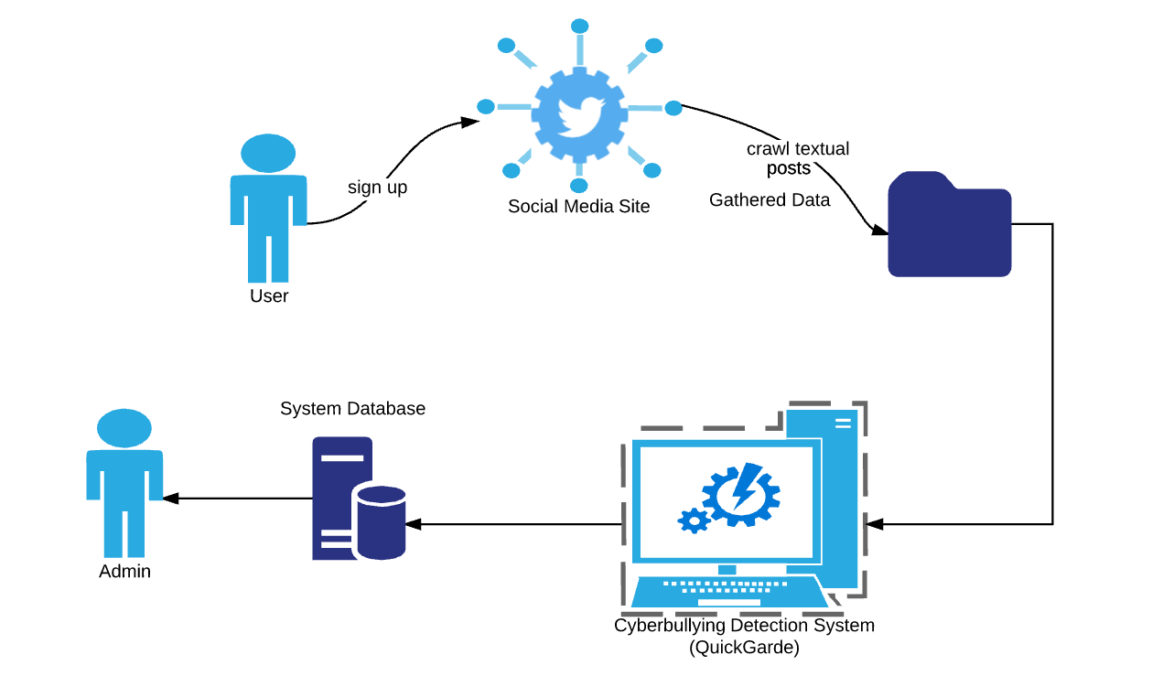

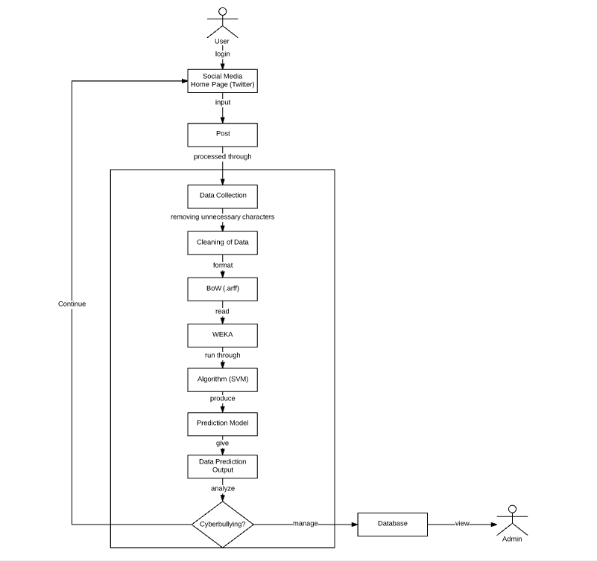

*Figure 4.1 System Architecture*

### **4.4.1 Data Collection**

Social networking sites such as Youtube, Facebook and Twitter were used as sources of data for the corpus. The dataset from Youtube contains comments from videos focusing on controversial events in the Philippines such as cases of bashing against Filipino celebrities and video bloggers, and scandals wherein politicians and celebrities are involved because these topics are often a rich source for objectionable and rude comments (Dinakar, Reichart & Lieberman, 2011).

In Facebook, several posts from the different universities' confession pages were collected because these pages allow anyone to share personal secrets, rumors, gossips, and anything else they might want others to know about but are hesitant to post publicly or in a way that is tied to their identity. Thus, the anonymity of the person posting a confession makes these pages vulnerable to cyber bullying activities. In Twitter, various posts from random Filipino netizens were obtained. Twitter is also prone to cyber bullying attacks since users can easily create fake accounts to launch their bullying cyber-attacks against people they don’t like or disagree with. In 2011, a study conducted by the University of Wisconsin-Madison found that 15,000 abusive tweets per hour, which equals 100,000 abusive tweets a week.

Import.io, a web scraping tool, was utilized to extract data from these social media sites. It is a tool which allows people to convert unstructured web data into a tabular format and store it in an Excel or CSV file. The only field in the table that was used in collecting data for the corpus was the textual content of the post while the other features such as the user information, links, and others were disregarded. A total number of 2000 statements written in Filipino and English were obtained.

The application, however, will acquire data directly from a social media site. In this project, Twitter will be the platform to be used since it has complete documentation regarding the methods on interacting with its API. A tool known as Twitter4J will be used to gather the tweets and respective information about them. Twitter4J provides a way for developers to integrate their Java application to the Twitter service.

### **4.4.2 Cleaning of the dataset**

The cleaning procedure that was applied on the dataset involved the removal of all special characters, non-readable text (e.g. asdfghjkl), emoticons, links, and characters belonging to various foreign countries' writing systems. This was done in order to prevent complications from arising particularly during the experimental phase of the project. Such characters do not make any sense with regard to the detection of cyberbullying occurrences, therefore their appearance may contribute to a probable decrease in the accuracy rate of the model. Basic Jejemon slang was likewise included in the dataset. Since the presence of distinct features were used as basis for the frequency of each word in every statement, it is important to include all words preserved in forms understandable by Filipinos within the dataset. This was procedure was done using regular expressions.

### **4.4.3 Data Annotation**

Once the preprocessing steps were accomplished, the dataset was further subjected to annotation. For this step, each data was classified into three labels: Cyberbullying, Non-Cyberbullying, and Ambiguous Cyberbullying (a case wherein the annotator was unable to identify whether a certain post implies cyberbullying or not). For this process, 100 questionnaires (that contains 10 sentences (with a total number of 2000 statements) taken from the corpus were distributed among Metro Manila citizens. The participants will manually label each data into three categories. Furthermore, the labeled data will be used in training the classifier.

### **4.4.4 Tokenization**

In this phase, all of the statements that were cleaned will be divided per each word within a particular statement based on the whitespaces separating them. This function will help provide each distinct occurrence of all the words that were part of the statements stored within the corpus. Once this process had been accomplished, it will determine the number of occurrences (frequency) of each feature as they occur in every statement. The acquired numerical values will then be used in the implementation of the Bag-of-Words.

### 4.4.5 Bag-of-Words

The dataset was transformed into a Bag-of-Words model, in which a set of text documents is converted into a numeric feature vectors wherein the order of word occurrences and grammar are ignored. It is primarily used as a tool of feature generation. The process begins by creating a list of unique words from the text. Once a list has been created, the number of times a word appears in a document will be computed. From the bag-of-words we removed all words that contained digits.

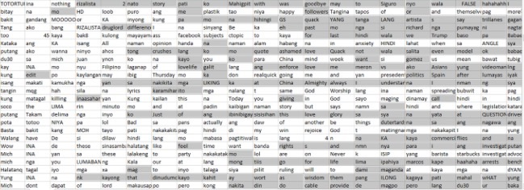

*Figure 4.2: Bag of Words Model*

After cleaning the dataset, the csv (comma-separated values) file was converted into .arff (Attribute-Relation File Format) format since it is the one being used in WEKA. In this format, the distinct features will be represented by the attributes, and the relation as the whole corpus itself. At the bottom part of the file, the number of occurrences (of each word in every statement) along with the annotations placed by both the researchers and their correspondents (in every statement), will be placed. Such data initially came from the .csv file containing the cleaned, parsed, and evaluated words comprising each of the 2000 statements.

### **4.4.6 Support Vector Machine**

Classification is the task of identifying the label for a single entity from a set of data. in order to determine cyberbullying from not-cyberbullying data, an SVM classifier was trained on a set of labeled data. Thus, these words are essentially treated as features that the classifier will use to model the positive instances of cyberbullying as compared to non-cyberbullying and ambiguous cyberbullying.

The Support Vector Machine algorithm was the only text classification algorithm that was used in the research project. It was implemented in the WEKA toolkit, a data processing and machine learning tool.

### **4.4.7 Cyberbullying Detection Model**

Among the 2000 statements, a total number of 900 was used for this experiment. The sole experiment that was performed involved the use of the Support Vector Machine (SVM) algorithm on, supposedly, the 2000 statements.

In this phase, the algorithm will be implemented together with the processed data in WEKA. The flagging of cyberbullying statements takes place in this phase. There will be charts that the tool will present to indicate how it classified a particular statement.

# **5. Results and Discussion**

## **5.1 Baseline Results**

For the first experiment, the model was evaluated against 500 testing data for each run and the labels assigned by the model were compared against the labels that were assigned to the classes during annotation. The overall number of data that was used in training the model was 1000. However, in order to determine how the number of data can affect the model’s performance, we increase the number of the training data for each run. To illustrate, we started with 200 data for the first run then added 300 more data for the second run. As for the third run, we added 200 more data and another 300 data for the fourth run. Table 5.0 depicts the accuracy and the kappa statistics of the model.

As seen in Table 5.0, there was a slight increase in the values of accuracy and kappa statistics as the number of training data increases. Thus, the model will be able to classify more correct instances if the number of training data was increased. As for the kappa statistics, the highest value yielded by the model was 0.2312 for the third run which implies that there was a fair agreement between the labels that were assigned by the annotators as well as to those that were assigned by the classifier. However, as shown in Table 5.0, a larger dataset may not always indicate a higher Kappa score as bias may likely to occur on the side of the annotator (Gwet, 2002).

|  |  |  |  |
| --- | --- | --- | --- |
| **# of Training Data** | **# of Testing Data** | **Accuracy** | **Kappa Statistics** |
| 200 | 500 | 49.5 | 0.1571 |
| 500 | 500 | 53.6 | 0.2152 |
| 700 | 500 | 54.5714 | 0.2312 |
| 1000 | 500 | 57.8889 | 0.2294 |

## **5.2 Percentage Split**

For this experiment, the dataset was divided into two parts: the training and testing. However, for each run, different splits was used. The purpose of this experiment is to determine the right split for our dataset. As shown in Table 5.1, the proper split for our dataset is 80/20.

|  |  |  |  |
| --- | --- | --- | --- |
| **Training Data (%)** | **Testing Data (%)** | **Accuracy** | **Kappa Statistics** |
| 66 | 44 | 45.8824 | 0.0911 |
| 70 | 30 | 47.3333 | 0.114 |
| 80 | 20 | 55 | 0.2177 |
| 90 | 10 | 50 | 0.1325 |

## **5.3 K-Fold Cross Validation**

For this set of experiments, we performed a non-exhaustive cross validation method called k-fold cross-validation wherein multiple rounds of cross-validations were used on the dataset using different partitions. The primary goal of conducting these experiments is to determine the number of folds which can be used that will result into a better predictive model. Table 5.1 summarizes the result of the experiments that were conducted.

|  |  |  |
| --- | --- | --- |
| **K-Fold** | **Accuracy** | **Kappa Statistics** |
| 2 | 57.65 | 0.1933 |
| 3 | 57.65 | 0.2007 |
| 4 | 58.2 | 0.2082 |
| 6 | 58.05 | 0.2096 |
| 7 | 58.15 | 0.2081 |
| 8 | 58.85 | 0.2288 |
| 9 | 56.95 | 0.2084 |
| 10 | 57.95 | 0.2094 |

*Table 5.1: K-Fold Cross Validation*

As shown in Table 5.1, the model can yield the highest accuracy and kappa score when the dataset was divided into 8 folds.

## **5.4 Comparison of Machine Learning algorithms**

For this experiment, the Support Vector Machine (SVM) was compared among the different performances of 11 other machine learning algorithms. Moreover, 10-fold cross validation was performed for each algorithm. Their performance were tested against 2000 data. The purpose of this experiment was to determine how each algorithm’s performance varies from one another and to identify the algorithm that is best suitable in classifying cyberbullying instances. Table 5.0 illustrates the comparison of the performance of the 12 machine learning algorithms used for our classification problem.

|  |  |  |
| --- | --- | --- |
| **Algorithm** | **Accuracy** | **Kappa Statistics** |
| **SVM** | 57 | 0.2094 |
| **Naïve Bayes** | 45.8 | 0.1272 |
| **J48** | 53.7 | 0.1619 |
| **ZeroR** | 56.9 | 0 |
| **Decision Stump** | 56.9 | 0 |
| **RandomTree** | 48.55 | 0.1008 |
| **RandomForest** | 61 | 0.1712 |
| **RepTREE** | 56.9 | 0.1026 |
| **HoeffdingTree** | 56.9 | 0 |
| **DesicionTable** | 58.8 | 0.1173 |
| **JRip** | 57.9 | 0.0594 |
| **OneR** | 55 | 0.0431 |

*Table 5.0: Comparison of the performances among 12 machine learning algorithms*

As shown in Table 5.0, RandomForest outperforms the performance of the other machine learning algorithms in terms of accuracy with a score of 61%. However, in terms of kappa statistics, SVM outperforms the others with a score of 0.2094. However, among the 12 machine learning algorithms used, J48 showed the lowest performance with an accuracy of 53.7 while ZeroR, Decision Stump, and HoeffdingTree have a kappa score of 0.

Since it is clearly difficult to differentiate the performance of the machine learning algorithms based on their accuracy and kappa scores alone (Williams, N. Zander, S. & Armitage, G., 2006), we also focused on the time taken in building each model known as the computational performance. Among the 12 algorithms, ZeroR took the shortest time in building the model with a time of 0.02 seconds.

|  |  |
| --- | --- |
| **Algorithm** | **Time (seconds)** |
| **SVM** | 47.56 |
| **Naïve Bayes** | 4.98 |
| **J48** | 61.84 |
| **ZeroR** | 0.02 |
| **Decision Stump** | 2.78 |
| **RandomTree** | 2.97 |
| **RandomForest** | 40.25 |
| **RepTREE** | 14.04 |
| **HoeffdingTree** | 17.19 |
| **DesicionTable** | 628.02 |
| **JRip** | 48.21 |
| **OneR** | 1.45 |

## **5.5 Expected Output**

The training phase was composed of steps on automating the manual procedures on the experimentation phase. The SVM classifier and preprocessing steps were programmed using Java in Eclipse IDE. In order to test this phase, the result was printed on a designated text file.



*Figure 5.3: An example of a user input in the console*

Once a text has been entered, the data was subjected to cleaning which involves the removal of unnecessary characters.



*Figure 5.4: An example of data cleaning procedure*

Moreover, the cleaned data was further partitioned into tokens or a list of words.

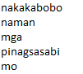

*Figure 5.5: Tokenization process*

Once the input was separated into a list of words, it was compared in an array of attributes derived from the Bag-of-Words model from the experimentation phase. This process was used in determining the frequencies of each word in the list. Once the number of word occurrences has been identified, the classifier determines whether the post implies cyberbullying or not. The output for this phase was printed on the console. Figure 5.6 shows the comparison between the actual class and the class that was predicted by the SVM classifier.

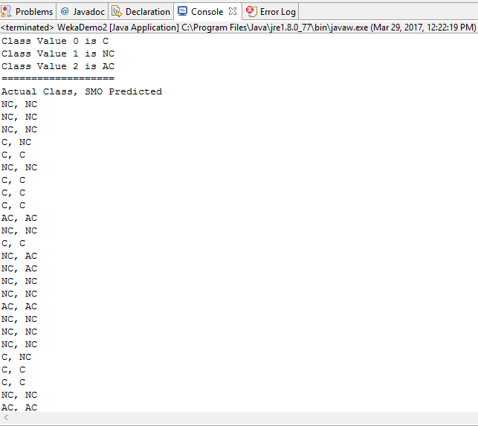

*Figure 5.6: SVM Classifier*

Thus, once a harmful post has been detected, the application will output the tweet along with its relevant information in a tabular format that is exclusively accessible by the social media sites administrators.

## **5.6 Data Description**

This section presents an in-depth description of the pre-processed textual corpus data in terms of its constituents’ characteristics and their contribution to the context of the statement (if any).

### **5.6.1 Length of words per statement**

The length of each word per statement was measured based on character count. Character count functions as a good indicator of how complex the sentences in the dataset are regarding the distribution of each of their words’ lengths in that particular sentence. Furthermore, in terms of computer architecture, a “word” pertains to data handled as a single unit. They are considered as “bits” that are processed altogether by the CPU. In the count, all characters - even numeric data, as long as they are not separated by spaces, is then considered a word or part of a word.  The graph below shows the distribution of word lengths in all of the sentences in the corpus.

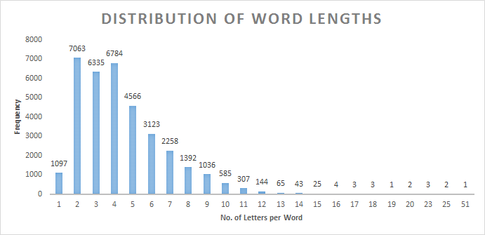

It can be inferred from the graph that sentences in the corpus are not composed of any complex ones. 2-letter words are the most dominant in the dataset, followed by 4-lettered and 3-lettered words, considering the fact that every sentence consists of an average of 76 characters or 17 words. It is highly probable to get a sentence made up mostly of these types of words instead of the longer ones out of the corpus.

### **5.6.2 Presence of numeric data**

The intent of excluding numeric data, specifically number combinations making use of the characters “0” to “9”, from the list of the characters to be removed is due to the fact that there are instances in the written, modern Filipino language when such characters will be combined together with the letters of the alphabet in order to form words. Such cases are present when either 2 of the Filipino shortcut texting styles or *Jejenese* - the language of the Jejemon subculture - were applied in the creation of the social media post.

There are 2 distinct styles of Filipino shorthand messages that make use of combined numbers and words - the *phonetic style* and *repeating units*. The phonetic style pertains to the substitution of similar sounding numeric characters, typically adapting the English pronunciation of the numbers, to their syllable counterparts (e.g. *i2* for the word *ito* (it/this) and *d2* for the word *dito* (here)). It can be noticed that the way the number “2” is pronounced is quite the same as that of the syllable “to” in the words *ito* and *dito*, and can therefore serve as its replacement in order to shorten the word without losing its context. This type of text messaging shortcut can also be considered as part of light *Jejenese*. On the other hand, the use of repeating units pertained to the substitution of a numeric character on a repeating syllable in a particular word. The numeral to be substituted will depend on the number of times the syllable will be repeated consecutively. For example, the word *aalis* (will leave) can be written as *a2lis*, since the syllable “a” was mentioned 2 consecutive times in that particular word.

The *Jejenese* language is defined as the language of the *Jejemons*. The term *Jejemon* pertains to individuals, typically Filipinos of the younger generation, who were able to create their own “written language” by forming words out of combined numbers, letters, and special characters (if applicable), typically characterized by alternate uppercase letters, overused Hs, Xs, and Zs, and rearranged characters (which would appear to form a letter when combined). They are often considered to be incomprehensible by those who are unfamiliar with the said “language”. Furthermore, there are no specific syntaxes for writing sentences in *Jejenese*. *Jejemons* were able to get a grasp of this “language” due to the influence of other *Jejemons* as well. Filipino people who are often engaged in social media adapt this simply because it is a trend.

|  |  |
| --- | --- |
| **Jejemon word/phrase** | **Original word/phrase** (In Filipino) |
| aq0uh | ako |
| bzt4h | basta |
| g34hin | gayahin |
| pWerA LnG iF tiNO2pAk aQ! | Pwera lang if tinotopak ako! |
| it'S harD 2 piCk uP d piEceS oF my liFe | It’s hard to pick up the pieces of my life |

*Sample words and phrases in Jejenese*

The dataset that was utilized in this research project yielded a total of 178 words, each of which consisted of at least 1 number. 120 statements contained those words. The most number of words bearing the same characteristics as mentioned in each of the 2000 statements in the corpus is 6, with 0 as the minimum. The graph below shows the percentage of numeric data in the dataset.

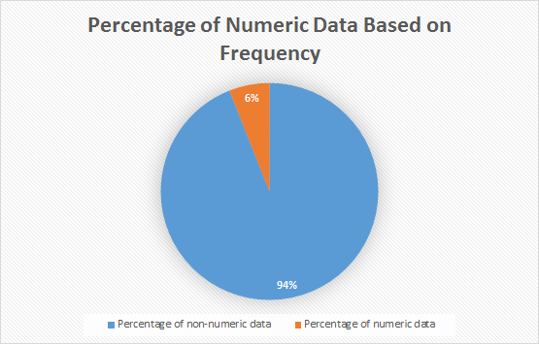

Based on the graph, it can be seen that the number of numeric data that remained in the corpus is very minimal. Having checked each numeric data occurrence per statement, the researchers were able to determine their nature in the dataset and function in the sentence. Numeric data are being used in the corpus to either pertain to a specific date or time (e.g. to mention a year in the post or the date and time the post was posted - it was included by the web scraper), create the cat-smile ( :3 ) emoji, count nouns (e.g. 40 days, 30 years), represent a cellphone model (e.g. 3310), indicate bible verses and television channels, utilize text messaging shortcuts (e.g. d2), or even drop a random statement.

While there are no concrete evidences of numbers being used as part of a cyberbullying keyword in the dataset, there were however some probable cyberbullying statements in which numbers played a part in. For instance, the statement  “*Mich bakit mo pinalitan si jam?  Hindi pa nga na ka 40 days si jam pinalitan mo na ang landi mo*”, apparently contained implications of cyberbullying, but the number merely functions as a support to the “*..ang landi mo*” statement. There were also instances wherein the numbers do not make sense at all unless the topic of the thread will be made known (e.g. “*isang 45 lang para sa pamilya ng mga suspek hahaha*”. Lastly, there were no instances of heavy *Jejenese* in the dataset - only those which were also used as text messaging shortcuts. These words did not imply cyberbullying as well.

As much as these types of words’ impact on the performance of the model remain minimal, there is still a need for them to be kept in the dataset, for when the researchers are able to gather more similar words, then the machine will be able to bear enough knowledge to uncover the differences between a cyberbullying and non-cyberbullying keyword.

### **5.6.3 Presence of words in uppercase**

Words expressed in all capital letters (or uppercase) likewise took a portion of the dataset. The proponents of the study decided to include them in the analysis part for most people regard them as a means of “shouting” typed text - which typically presents a negative connotation. It was mentioned from a source that words in all capital letters did not necessarily imply “loudness” during the early days. In fact, they were only utilized to convey the importance of a word in the statement. The said implication may have stemmed from the fact that uppercase words occupy larger spaces, in comparison to words in lowercase, giving them more visibility and the feeling of overcrowdedness.

There are currently 2428 uppercase words contained within the dataset. Only 332 out of the 2000 statements acquired were consisted of these uppercase words. The maximum number of uppercase words in a single statement is 114, with 0 as the minimum.  The following graph illustrates the percentage of uppercase words in the dataset in terms of frequency.

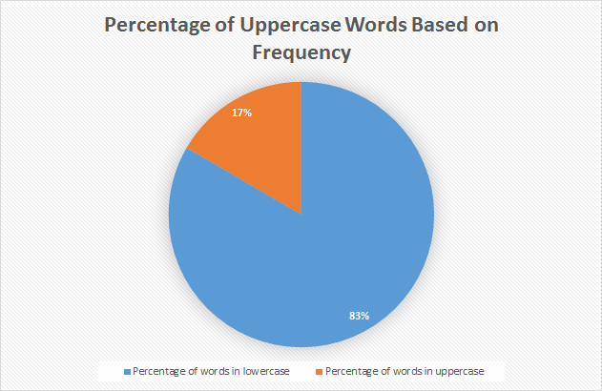

There are a lot of uppercase words in the dataset that served as indicators of cyberbullying, either on their own or when combined with another set of words. For instance, the statement with the most number of uppercase words in the corpus that goes, “*IM HERE AGAIN O PAANO SENATOR NA SI MANNY PAQUIAO MY IDOL PERO KAYONG MGA SUMUSUBO NG ETITS NG KAPWA LALAKE EH NANANATILI PA RING MASAHOL SA HAYOP LALO KA NA BOY ABUNDAT! PURO KA DAKDAK SI MANNY SIKAT PA DIN PERO KAYONG MGA MASAHOL SA HAYOP EH NASAAN NA KAHIT KAILAN HINDI MANANAIG ANG MASAMA SA MABUTI*”, likewise contained the most number of cyberbullying references in it when compared to the rest of the statements. The harmfulness of the post also appeared to be doubled due to it being in all capital letters. However, not all words in uppercase are semantically offensive. People also type this way to express excitement (e.g. “*OMFG SHIT YAAAAAAAAAAS”*) or mention abbreviated words (e.g. KMJS which stands for Kapuso Mo Jessica Soho - a television segment).

### **5.6.4 Presence of words consisting of single or double characters**

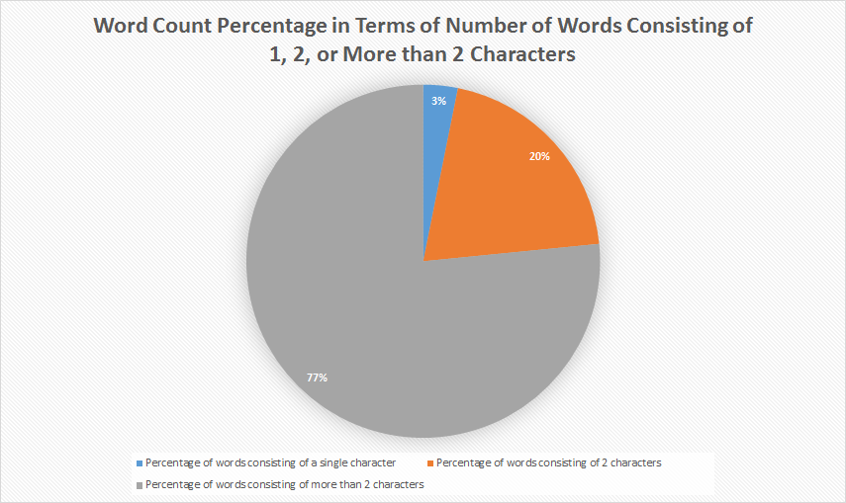

A total of 8161 words made up of single and double characters remained in the dataset. The number of words with double characters took up the larger portion (with 7063 characters in total), contrary to those in single characters (1098 characters). They were kept in the dataset to train the algorithm to become familiar with the different usages of Filipino shortcut messages, as they are almost always present in every social media post. However, apart from being used as word shortcuts, majority of these characters in the dataset were reduced to meaningless characters due to the removal of special characters such as the apostrophe, period and hyphen, which binds them in their original words for them to convey their statement’s context properly.

The tables below illustrate such instances of single characters separated from their original word(s) as a result of the cleaning of the dataset.

|  |  |
| --- | --- |
| **Separated single characters**  (by apostrophe) | **Originally part of the following word(s)** |
| I | I’m, I’ve |
| m | I’m |
| s | who's, she's,it's, that's, God's, Peter's, Manny's, there's, where's, what's, he's, Vice's,  everybody's, Pinoy's, attorney's, what's, Rizal's, dean's, night's, father's, China's, Hague's, Duterte's, PHL's (Philippine's), fool's, let's, Pilipino's, one's, someone's |
| t | don't, wasn't, can't, didn't, isn't, doesn't, na't, won't, isa't, couldn't, wouldn't, aren't, gov’t (government) |
| y | y’all |

|  |  |
| --- | --- |
| **Separated single characters**  (by period) | **Originally part of the following abbreviations** |
| a | a.k.a (also known as) |
| k | a.k.a (also known as) |
| o | o.c. (obsessive compulsive) |
| c | o.c. (obsessive compulsive) |
| U | U.S. (United States) |
| S | U.S. (United States) |
| t | t.v. (television) |
| v | t.v. (television) |
| p | p.i. (putang ina) |
| i | p.i. (putang ina) |

The subsequent table, on the other hand, presents instances of “words” consisting of double characters separated from their original word(s). It is also noticeable that their amount is smaller in comparison to their single character counterpart.

|  |  |
| --- | --- |
| **Separated double characters**  (by apostrophe) | **Original word(s)** |
| re | you’re, we’re |
| ve | you’ve |

Additionally, there were instances in the dataset of both single and double characters being used as shortcuts for different words in each of the statements. The following are some examples.

|  |  |
| --- | --- |
| **Single characters**  (used as shortcuts) | **Original word** |
| b | ba |
| c | si |
| d | hindi |
| f | fuck |
| G | Vice G. (used as shortcut for the surname) |
| g | sige or (literally “game”) |
| k | ka or ko |
| m | mo |
| n | na |
| p | pa |
| q | ko |
| r | are |
| s | sa |
| u | you |
| w | with |
| y | why |

|  |  |
| --- | --- |
| **Double characters**  (used as shortcuts) | **Original word** |
| xa | sa |
| db | hindi ba or di ba |
| ky | kay |
| to | ito |
| kb | ka ba |
| aq | ako |
| di | hindi |
| yn | yan |
| bt | bakit |
| kc | kasi |
| em | I’m |
| nw | now |
| un | yun |
| qt | cutie |
| rt | Retweet (Twitter term) |
| dm | Direct Message (Twitter term) |
| ur | you are or you’re |
| tf | the fuck (from “What the fuck”) |
| vs | versus |
| te | ate |
| ko | Ako or abbreviation of the word “knockout” |

So far, the dataset does not contain instances of separated single characters that were used to be conjoined by hyphenated words, similar to that of the double characters. Other functions of words consisted of single characters involve representing numbers, the pronoun “I”, the article “a”, the Tagalog word “o”, ambiguous usage of letters “s” and “G” in a sentence (e.g. “*Ngayon ko lang napansin na wala palang S ung girl S*” and “*May mga kasalanan ka den G”* - unless the “G” there functions as someone’s initials), the Tagalog expression “e” - sometimes written as “eh”, removed “:” from emoticons - leaving only the letters that follow after it, and the use of the letter “x” to pair people together (e.g. Ibanez x Squier). Lastly, there were inconceivable usages of double characters as well all over the dataset. Characters such as “*n1-n9*” and “âœ” are some examples.

Words made up of double characters, if not comprehensible, are typically prepositions such as up, in, on, etc., adverbs such as so, etc., *pang-ukol* (Tagalog prepositions) such as *sa*, *ng*, etc., *panghalip* (pronouns) such as *ka* or *ko*, *pang-abay* (adverbs) such as na, pa, etc., and *pangatnig* (conjunctions) such as *at*, *ni*, etc.

### **5.6.5 Top 50 cyberbullying keywords**

The following are the top 50 most recurrent words among all statements or sentences annotated as “cyberbullying” in the dataset. They were also based on several sources indicating the top cyberbullying keywords that can be found in posts created by Filipinos in social media.

|  |  |  |
| --- | --- | --- |
| **Rank** | **Word(s)** | **No. of occurrences** |
| 1 | INA/unu | 566 |
| 2 | TANG/tung | 210 |
| 3 | puta/putang/pota/PUTANGINA/pokeng | 155 |
| 4 | Hahahaha/Hihi/Hehehe | 153 |
| 5 | baba | 137 |
| 6 | gay | 122 |
| 7 | fuck/fucking/FUCKIN/pakyu | 97 |
| 8 | HAYOP/KABAYO/ANIMAL/daga/pet/baboy | 95 |
| 9 | mamatay/hell/Kill/patay/bitayin | 93 |
| 10 | LANDI/itch | 88 |
| 11 | gang | 70 |
| 12 | pusher/druglord/lord/drug | 70 |
| 13 | tawa/Kakatawa | 69 |
| 14 | BIG | 64 |
| 15 | gago/tado | 62 |
| 16 | King | 61 |
| 17 | tanga/ulol/ulul | 52 |
| 18 | gaga | 47 |
| 19 | malandi/Kalandi/baliw/abnoy | 45 |
| 20 | loko | 42 |
| 21 | bakla/Kadiri | 41 |
| 22 | ass/Butt | 39 |
| 23 | che | 37 |
| 24 | mahina/matanda/slow | 37 |
| 25 | hiya | 35 |
| 26 | bitch/tarantado | 35 |
| 27 | bobo/stupid/kupal | 33 |
| 28 | bad | 30 |
| 29 | paa/TAE | 29 |
| 30 | panga | 26 |
| 31 | wawa/Kaawa | 26 |
| 32 | baho/kati | 25 |
| 33 | punyeta/shit/bwiset/Bullshit | 24 |
| 34 | tangina | 23 |
| 35 | yaya | 23 |
| 36 | adik/salot | 22 |
| 37 | mahirap | 21 |
| 38 | pabebe/epal | 21 |
| 39 | malaki | 17 |
| 40 | pangit | 17 |
| 41 | BLACK/FAT/Blind/sunog | 17 |
| 42 | Bayag/pepe/etits/tuwad/pakantot /boobs/penis | 17 |
| 43 | Kapal | 15 |
| 44 | Yuck/Ewww | 8 |
| 45 | HYPOCRITE/pathetic | 6 |
| 46 | bruha/halimaw | 6 |
| 47 | demonyo | 4 |
| 48 | yawa | 4 |
| 49 | engot | 3 |
| 50 | inarte | 1 |

It can be noticed that in the first 10 cyberbullying keywords, profane words are the most dominant, specifically the many variations of the word *putangina*. Likewise, there were keywords implying threats (e.g. *patayin* - literally means “to kill” and *bitayin* - “to submit to torture”), and insults (e.g. *landi*, *baboy*,cand *baba* - which means “chin” in Tagalog but is often used an alias to call people with prominent chin). The last 10, however, are dominant on expressing insults - either physical, behavioral, and mental. It also included a set of words which are meant to pertain to both male and female sex organs, typically used to imply lustful desires toward a person, or perhaps a stranger.

# **BIBLIOGRAPHY**

Books

Boehm, C. (2012). *Moral Origins: The Evolution of Virtue, Altruism, and Shame*. New York, New York: Basic books (Perseus Books Group).

Goffman, E. (1956). *The Presentation of Self in Everyday Life*. New York, New York: Random House.

Salton, G. & McGill, M.J. (1986). *Introduction to Modern Information Retrieval*. New York, New York: McGraw-Hill Inc.

Research Papers

Busemann, S., Schmeier, S. & Arens, R. (2000, April 29). Message Classification in the Call Center, Proceedings of the sixth conference on Applied natural language processing, Seattle, Washington, April 29 – May 4, 2000. Stroudsburg, PA, USA: Association for Computational Linguistics

Cheng, C., & Ng, A. (2016). Automated Role Detection in Cyberbullying Incidents, Proceedings of the 16th Philippine Computing Science Congress, Puerto Princesa, Palawan, Philippines, March 16 – 18, 2016. Quezon City, Metro Manila, Philippines: Computing Society of the Philippines

Dadvar, M., & De Jong, F. (2012). Cyberbullying detection: A step toward a safer internet yard, Proceedings of the 21st International Conference on World Wide Web, Lyon, France, April 16 – 20, 2012. New York, New York: Association for Computing Machinery

Dadvar, M., De Jong, F., Ordelman, R., & Trieschnigg, D. (2012). Improved Cyberbullying Detection Using Gender Information, Proceedings of the Twelfth Dutch-Belgian Information Retrieval Workshop, Ghent, Belgium, February 23 – 24, 2012. Ghent, Belgium: Ghent University

Dinakar, K., Reichart, R., & Lieberman, H. (2011). Modeling the Detection of Textual Cyberbullying, International AAAI Conference on Web and Social Media, Barcelona, Catalonia, Spain, July 17 – 21, 2011. Menlo Park, California: The AAAI Press

Ellwood-Clayton, B. (2006). All we need is love—and a mobile phone: texting in the Philippines, Cultural Space and Public Sphere in Asia 2006, Korea Broadcasting Institute, Seoul, March 17 – 18, 2006.

Gonzales, R. (2014). Social Media as a channel and its Implications on Cyber Bullying, DLSU Research Congress 2014, De La Salle University, Manila, Philippines, March 6 – 8, 2014. Manila, Philippines: De La Salle University

Kwok, I., & Wang, Y. (2013). Locate the Hate: Detecting Tweets against Blacks, Proceedings of the Twenty-Seventh AAAI Conference on Artificial Intelligence**,** Bellevue, Washington, July 14 – 18, 2013. Palo Alto, California: Association for the Advancement of Artificial Intelligence

Lam, A., Paner, I., Macatangay, J., & Delos Santos, D. (2014). Classifying Typhoon Related Tweets, 10th National Natural Language Processing Research Symposium, De La Salle University, Manila, Philippines, February 21 – 22, 2014. Manila, Philippines: De La Salle University

Litvak, M., & Last, M. (2008, August 23). Graph-based Keyword Extraction for Single-document Summarization, Proceedings of the workshop on Multi-source Multilingual Information Extraction and Summarization, Manchester, United Kingdom, August 23 - 23, 2008. Stroudsburg, PA, USA: Association for Computational Linguistics

Peersman, C. Daelemans, W. Vaerenbergh, L. (2011). Predicting Age and Gender in Online Social Network, Proceedings of the 2011 International Workshop on Search and Mining User-generated Contents, Glasgow, Scotland, UK, October 28, 2011. New York, New York: Association for Computing Machinery

Pinto, A., Oliveira, H.G., & Alves, A.O. (2016). Comparing the Performance of Different NLP Toolkits in Formal and Social Media Text, 5th Symposium on Languages, Applications and Technologies, Maribor, Slovenia, June 20 – 21, 2016. Saarbrücken/Wadern, Germany: Schloss Dagstuhl – Leibniz-Zentrum für Informatik GmbH

Van Hee, C., et. al (2015). Automatic Detection and Prevention of Cyberbullying, HUSO 2015: The First International Conference on Human and Social Analytics, St. Julians, Malta, October 11 – 16, 2015. Wilmington, DE: International Academy, Research and Industry Association

Journals

Awad, W., & Elseofi, S. (2011). Machine Learning Methods for Spam Email Classification. *International Journal of Computer Science & Information Technology*, *3*(1), pp. 173–184.

Campbell, M. (2005). Cyber bullying: An old problem in a new guise?. *Australian Journal of Guidance and Counselling*, *15*(1), pp. 68-76.

Hinduja, S., & Patchin, J. (2007). Offline Consequences of Online Victimization: School Violence and Delinquency. *Journal of School Violence*, *6*(3), pp. 89-112.

Jones, K.S. (1972). A statistical interpretation of term specificity and its application in retrieval. *Journal of Documentation, 28*(1), pp. 11-21.

Madnani, N. (N.D). Getting Started on Natural Language Processing with Python. *ACM Crossroads*, *13*(4), pp. 5-5.

Marathe, S., & Shirsat, K. (2015). Contextual Features Based Naïve Bayes Classifier for Cyberbullying Detection on YouTube. *International Journal of Scientific & Engineering Research*, *6*(1), pp. 1109–1114.

Minor, M., Smith, G., & Brashen, H. (2013) Cyberbullying in Higher Education. *Journal of Educational Research and Practice 2013*, *3*(1), pp. 15–29

Sebastiani, F. (2002). Machine Learning in Automated Text Categorization. *ACM Computing Surveys*, *34*(1), pp. 1–47.

Sheoran, J. (2012). Technological Advancement and Changing Paradigm of Organizational Communication. *International Journal of Scientific and Research Publications*, *2*(12).

Sivic, Josef (April 2009). Efﬁcient visual search of videos cast as text retrieval. *IEEE Transactions on Pattern Analysis and Machine Intelligence*, *31*(4), pp. 591–605.

Smith, P., et al. (2008). Cyberbullying: its nature and impact in secondary school pupils. *Journal of Child Psychology and Psychiatry*, *49*(1), pp. 376–385.

Van Royen, K., Poels, K., Daelemans, W. & Vandebosch, H. (2015, February). Automatic monitoring of cyberbullying on social networking sites: From technological feasibility to desirability. *Telematics and Informatics*, *32*(1), pp. 89-97.

Vapnik, V., & Cortes, C. (1995, September). Support-Vector Networks. *Machine Learning*, *20*(3), pp. 273-297.

Wahbeh, A., & Al-Kabi, M. (2012). Comparative Assessment of the Performance of Three WEKA Text Classifiers Applied to Arabic Text*. ABHATH AL-YARMOUK: "Basic Sci. & Eng."*, *21*(1), pp. 15- 28.

Williams, N., Zander, S. & Armitage, G. (2006). A preliminary performance comparison of five machine learning algorithms for practical IP traffic flow classification. *ACM SIGCOMM Computer Communication Review*, *36*(5), pp. 5-16.

Dissertations

Lewis, D. D. (1992). *Representation and Learning in Information Retrieval* (Doctoral dissertation). Retrieved from UMI. (GAX92-19460)

Sintaha, M., Satter, S., Zawad, N., Swarnaker, C. & Hassan, A. (2016). *Cyberbullying Detection using Sentiment Analysis in Social Media* (Unpublished doctoral dissertation). Department of Computer Science & Engineering, BRAC University, Dhaka, Bangladesh

Web Articles

Digital in 2017: Global Overview. (2017, January 24). Retrieved from http://wearesocial.com/sg/blog/2017/01/digital-in-2017-global-overview

Lacuata, R. (2014, June 27). *How cyberbullying changed 'Amalayer' girl*. Retrieved from <http://news.abs-cbn.com/lifestyle/06/26/14/how-cyberbullying-changed-amalayer-girl>

RA 10627: The Anti-Bullying Act. (2015, January 22). Retrieved from http://www.elegal.ph/republic-act-no-10627-the-anti-bullying-act/

Republic Act No. 10627. (2013, September 12). Retrieved from http://www.gov.ph/2013/09/12/republic-act-no-10627/

Takumi, R. (2016, March 30). *FROM HUMILIATION TO THREATS: Survey says 80% of young teens in PHL experience cyberbullying*. Retrieved from http://www.gmanetwork.com/news/story/560886/lifestyle/parenting/80-of-young-teens-in-phl-experience-cyberbullying-survey

Torres, M. (2016). *Netizens react to Monster radio DJ Karen Bordador's arrest*. Retrieved from <https://kami.com.ph/40852-monster-radio-dj-karen-bordadors-arrest-stirs-netizens.html>

Tulad, V. (2012). *Cyberbullying: A victim's tale of lies and the madness of crowds*. Retrieved from <http://www.gmanetwork.com/news/story/274156/hashtag/cyberbullying-a-victim-s-tale-of-lies-and-the-madness-of-crowds>

What is Cyberbullying?. (2011). Retrieved from https://www.stopbullying.gov/cyberbullying/what-is-it/index.html